**E**stimation **A**nd **C**onfidence **I**ntervals

**Background**

In quality control processes, especially when dealing with high-value items, destructive sampling is a necessary but costly method to ensure product quality. The test to determine whether an item meets the quality standards destroys the item, leading to the requirement of small sample sizes due to cost constraints.

**Scenario**

A manufacturer of print-heads for personal computers is interested in estimating the mean durability of their print-heads in terms of the number of characters printed before failure. To assess this, the manufacturer conducts a study on a small sample of print-heads due to the destructive nature of the testing process.

**Data**

A total of 15 print-heads were randomly selected and tested until failure. The durability of each print-head (in millions of characters) was recorded as follows:

1.13, 1.55, 1.43, 0.92, 1.25, 1.36, 1.32, 0.85, 1.07, 1.48, 1.20, 1.33, 1.18, 1.22, 1.29

**Assignment Tasks**

**a. Build 99% Confidence Interval Using Sample Standard Deviation**

Assuming the sample is representative of the population, construct a 99% confidence interval for the mean number of characters printed before the print-head fails using the sample standard deviation. Explain the steps you take and the rationale behind using the t-distribution for this task.

Solution:

Formula for confidence interval for the mean is :

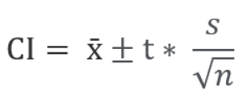

Given sample data : 1.13, 1.55, 1.43, 0.92, 1.25, 1.36, 1.32, 0.85, 1.07, 1.48, 1.20, 1.33, 1.18, 1.22, 1.29

Step-1: Mean of the sample data = 1.24 (Calculated using python)

Step-2: Standard deviation of sample data (sd)= 0.19 (Calculated using python)

Step-3: Critical value from t-Distribution:

Degrees of freedom (df) = n−1=15 - 1=14

value = 2.977

Source: https://www.sjsu.edu/faculty/gerstman/StatPrimer/t-table.pdf

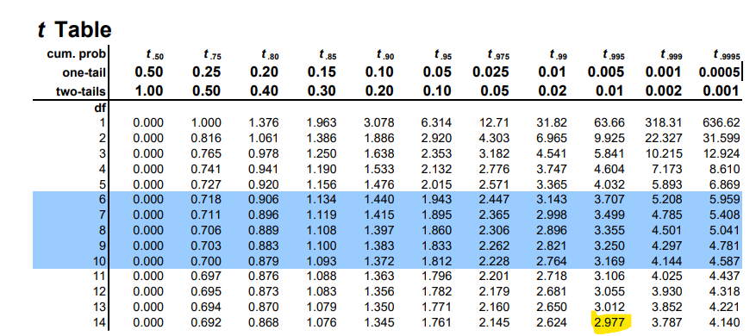

Step-4: Standard Error of the Mean (SEM):

SEM= sd/sqrt(n)

SEM = 0.05

Step-5 : 99% Confidence Interval can be calculated as :

Confidence Interval = xˉ±t∗×SEM = (1.38885, 1.09115)

Conclusion : The 99% confidence interval for the mean number of characters printed before a print-head fails is approximately (1.38885, 1.09115)**million characters**.

**b. Build 99% Confidence Interval Using Known Population Standard Deviation**

If it were known that the population standard deviation is 0.2 million characters, construct a 99% confidence interval for the mean number of characters printed before failure.

Solution:

Population standard deviation is given as 0.2 million characters

Sample size = 15

Sample mean = 1.24

For a 99% confidence level, the critical value from the standard normal distribution (Z-table) is approximately **2.576**.

Source : <https://www.sjsu.edu/faculty/gerstman/StatPrimer/t-table.pdf>

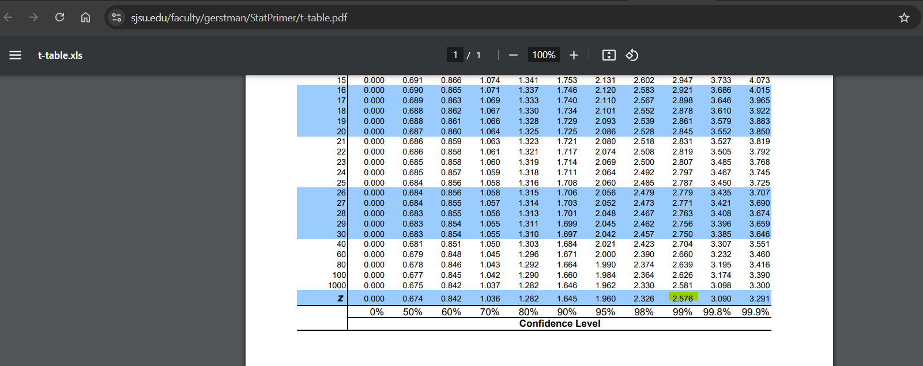

Formula for the confidence interval for the mean when the population standard deviation is known is given by:

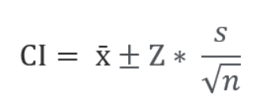

CI = (1.3688, 1.1112)

Conclusion:

The 99% confidence interval for the mean number of characters printed before a print-head fails, using the known population standard deviation of 0.2 million characters, is approximately (1.3688, 1.1112)**million characters**.